CLOUD COMPUTING USING JAVA
Internship Report
Submitted to
UNIVERSITY OF MADRAS
In partial fulfilment for the
requirement of the Degree
BACHELOR OF COMPUTER APPLICATIONS
During the academic year
June 2025 to October 2025
Submitted by
Ms. ASWINI A
Register No : 212302669
Under the Guidance of
Mrs. A. PADMINI, MCA, M.Phil.
Asst. Professor
DEPARTMENT OF COMPUTER APPLICATIONS


VALLIAMMAL COLLEGE FOR WOMEN

E-9, Anna Nagar East, Chennai – 600 102.

VALLIAMMAL COLLEGE FOR WOMEN

E-9, Anna Nagar East, Chennai - 600 102.

DEPARTMENT OF COMPUTER APPLICATIONS

BONAFIDE CERTIFICATE

This is to certified that this internship report titled by “CLOUD COMPUTING USING JAVA” is a Bonafide record of internship work done by Ms. ASWINI A under our supervision and guidance, towards partial fulfilment of the requirements for award of the Degree BCA during the academic year 2025 to 2026.

STAFF INCHARGE HEAD OF THE DEPARTMENT

HEAD OF THE INSTITUTION

Submitted for BCA Degree internship work held on……………………………………...at
VALLIAMMAL COLLEGE FOR WOMEN, CHENNAI – 600102

DATE : EXAMINERS :
1.
2.
ACKNOWLEDGEMENT

First of all, I thank God who has given me power and knowledge to complete the project successfully.
I take great and immense pleasure to express my deep sense of obligation to our management and guided in all our endeavour. I extend my sincere thanks to the Principal Dr .T.V.S. PADMAJA for her support and guidance.
I express my profound thanks to the Head of the department and guide Mrs. A. PADMINI for her continuous encouragement and timely guidance in completing this Internship work.
I would like to extend my thanks to all other Staff Members of the Department of Computer Applications who have helped me by providing all facilities to complete this internship successfully and I also like to express my hearty thanks to my beloved parents who always encourage me in the path of success.




 | INDEX
S.NO | CONTENT | PG.NO
1 | ABOUT THE COMPANY | 1
2 | INTRODUCTION TO CLOUD COMPUTING | 4
3 | CLOUD SERVICE & DEPLOYMENT MODELS | 8
4 | INTRODUCTION TO JAVA | 11
5 | FRONTEND DEVELOPMENT | 15
6 | BACKEND DEVELOPMENT | 21
7 | DATABASE MANAGEMENT | 24
8 | API DEVELOPMENT | 28
9 | CLOUD INTEGRATION WITH JAVA | 32
10 | TOOLS & FRAMEWORKS USED | 35
11 | TESTING & DEBUGGING | 38
12 | SECURITY IN CLOUD APPLICATIONS | 41
13 | DEPLOYMENT & DEVELOPS | 44
14 | CONCLUSION | 47

INTERNSHIP
REPORT

CLOUD COMPUTING USING JAVA

1. ABOUT THE COMPANY

In a digitally connected world, where innovation and technology define the competitive landscape, Virtual Techz Services emerges as a beacon of excellence in the realms of software development and cutting-edge CCTV product solutions. With a history steeped in innovation and a commitment to customer-centric practices, we have positioned ourselves as a key player in the technology and surveillance industry.

COMPANY OVERVIEW :
Virtual Techz Services is a hub of creativity, where software development transcends mere coding and programming. Our dynamic team of seasoned software engineers and developers is dedicated to crafting custom-tailored software solutions that address the ever-evolving needs of our clients. From robust enterprise software to user-friendly mobile applications, we are the architects of digital transformation, working tirelessly to make technology accessible and efficient.

COMMITMENT :
At the heart of Virtual Techz Services lies an unwavering commitment to excellence and innovation. Our mission is not solely focused on the creation of superior software and surveillance solutions. Rather, it encompasses an even loftier goal – the cultivation of lasting customer relationships. We understand that our success hinges on the trust and satisfaction of our clients. Consequently, our company places substantial emphasis on delivering superlative customer experiences, ensuring customer delight, and nurturing enduring relationships.

MISSION :
At Virtual Techz Services, our mission is to deliver exceptional customer experiences by seamlessly integrating cutting-edge software solutions and CCTV products into our clients' lives. We are dedicated to forging lasting, mutually beneficial relationships while providing innovative, secure, and user-centric technology services that empower individuals and organizations to thrive in an increasingly digital world.
SECURITY AND PRIVACY :
We understand that the security and privacy of our clients' data are not negotiable. They are non-negotiable. We maintain an unwavering commitment to adhering to the most stringent security standards and privacy protocols. Our clients can have confidence that their sensitive information is safeguarded at every step, and our dedication to this responsibility is unyielding.

CONTINUOUS IMPROVEMENT :
Continuous improvement is embedded in our organizational DNA. We value feedback from our clients, team members, and stakeholders, viewing it as a crucial driver of growth and excellence. We use this feedback to inform and evolve our processes, products, and offerings continually. This commitment to learning and improvement ensures that we are always at the forefront of industry best practices and equipped to provide the best possible solutions and experiences.

SUSTAINABILITY:
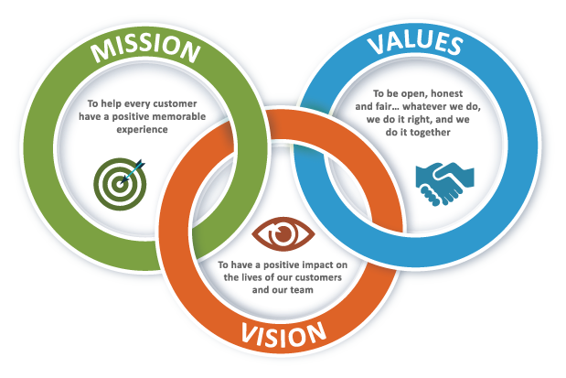
We are acutely aware of the environmental and social impact of our work. Sustainability is not merely a buzzword but a core principle that guides our actions. We are committed to developing and promoting technology solutions that positively contribute to a sustainable future. Our dedicationto sustainability extends beyond the present, with a focus on ensuring that our actions today leave a lasting positive legacy for future generations.

COMPANY HISTORY :
Virtual Tech Services was founded in 2001. Virtual Tech Services has been listed on the Shenzhen Stock Exchange since 2010. In October 2016, the company concluded a deal with the industry to use computer vision technology. In May 2017, Virtual Tech Services established storage, a subsidiary focused on the production of storage devices. In January 2021, the company won a smart city project that includes cameras with facial recognition and license plate recognition technologies.
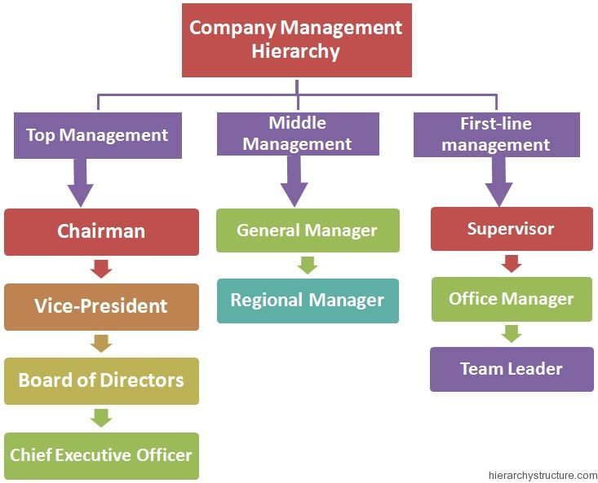
In 2022, Virtual Tech Services was awarded an Industry contract to develop software to track "key people" in order to prevent them from entering Beijing. Amazon Web Services provides cloud services to Virtual tech Services. In 2023, Virtual Tech Services released software that includes ethnic minority detection.

2. INTRODUCTION TO CLOUD COMPUTING

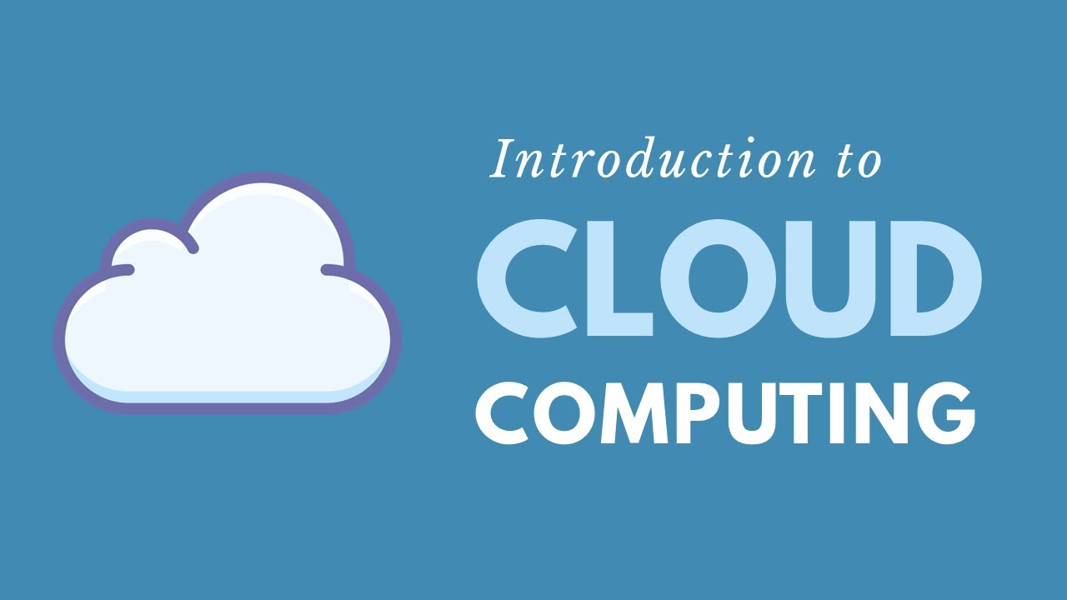
Cloud computing is a growing technology which could change traditional IT systems. Cloud computing makes it feasible for an organization IT to be more flexible, save costs and process information and data faster than with traditional IT. The problem though lies in the riskiness of this new technology.

Cloud computing has recently emerged as a new paradigm for hosting and delivering services over the Internet Cloud computing is attractive to business owners as it eliminates the requirement for users to plan ahead for provisioning, and allows enterprises to start from the small and increase resources only when there is a rise in service demand. However, despite the fact that cloud computing offers huge opportunities to the IT industry, the development of cloud computing technology is currently in its infancy, with many issues still to be addressed.
Cloud computing has gained a lot of publicity in the current world of IT. Cloud computing is said to be the next big thing in the computer world after the internet. Cloud computing is the use of the Internet for the tasks performed on the computer and it is visualized as the next generation architecture of IT.

2.1 EVOLUTION OF CLOUD COMPUTING
Early foundations (1950s–1980s)
- Cloud computing's roots trace back to the 1950s and 1960s with mainframe computing, where powerful centralized machines handled multiple users through time-sharing. This allowed remote access to computing resources but involved large, expensive systems mainly used by big organizations. The 1970s introduced virtualization, a critical technology that created virtual machines over physical hardware, enabling multiple workloads to share computing resources efficiently—a cornerstone for cloud infrastructure today.
- During the 1970s and 1980s, distributed systems and cluster computing emerged, connecting multiple machines to act as a single resource for enhanced performance and availability. However, these early systems were limited by geographical constraints and network bandwidth. To address this, grid computing in the 1990s linked geographically dispersed and heterogeneous resources over the internet, setting the stage for cloud services but still facing challenges in connectivity and efficiency.
The Internet Era and Web 2.0 (1990s–2000s)
- The rapid growth of the internet and the invention of the World Wide Web in the late 1980s and early 1990s provided the infrastructure needed for cloud computing to expand. Web 2.0 technologies, popularized around 2004, brought dynamic, interactive web applications like Google Maps and Facebook, which enhanced cloud service interfaces and usability.
- During this period, the concept of utility computing gained traction, envisioning computing resources provided like utilities (electricity, water), where users pay only for what they consume. This perspective was realized by distributed computing models delivering
- infrastructure, platforms, and software as on-demand services over the internet.
Modern Cloud Computing and Major Players (2000s–2010s)
- Cloud computing shifted to mainstream adoption with pioneers like Amazon Web Services (AWS) launching in 2002 and introducing Elastic Compute Cloud (EC2) in 2006. This allowed businesses and developers to rent virtual servers on demand, radically lowering entry costs and improving scalability.
- Following AWS, Google Cloud and Microsoft Azure, launched in the late 2000s and early 2010s, expanded cloud offerings through Platform as a Service (PaaS) and Software as a Service(SaaS) models, providing managed platforms and ready-to-use applications accessible via browsers. These advances enabled rapid application development and flexible IT infrastructure management.
Cloud computing models became categorized as:
- Infrastructure as a Service (IaaS): Virtualized hardware resources (e.g., AWS EC2).
- Platform as a Service (PaaS): Managed platforms for development (e.g., Google App Engine).
- Software as a Service (SaaS): End-user software applications online (e.g., Google Drive, Salesforce).
Advancements and Trends (2010s–Present)
- The 2010s witnessed the growth of hybrid clouds combining public and private cloud benefits, supported by open-source projects like OpenStack. Innovations such as containerization (Docker) and orchestration (Kubernetes) emerged, facilitating microservices architecture and agile deployments.
- The rise of serverless computing (e.g., AWS Lambda) allowed developers to focus solely on code without managing servers, increasing efficiency. Artificial intelligence (AI) and machine learning (ML) integration into cloud services enhanced automation, analytics, and intelligent applications.
- The COVID-19 pandemic accelerated cloud adoption globally by enabling remote work, increasing cloud market revenues dramatically.
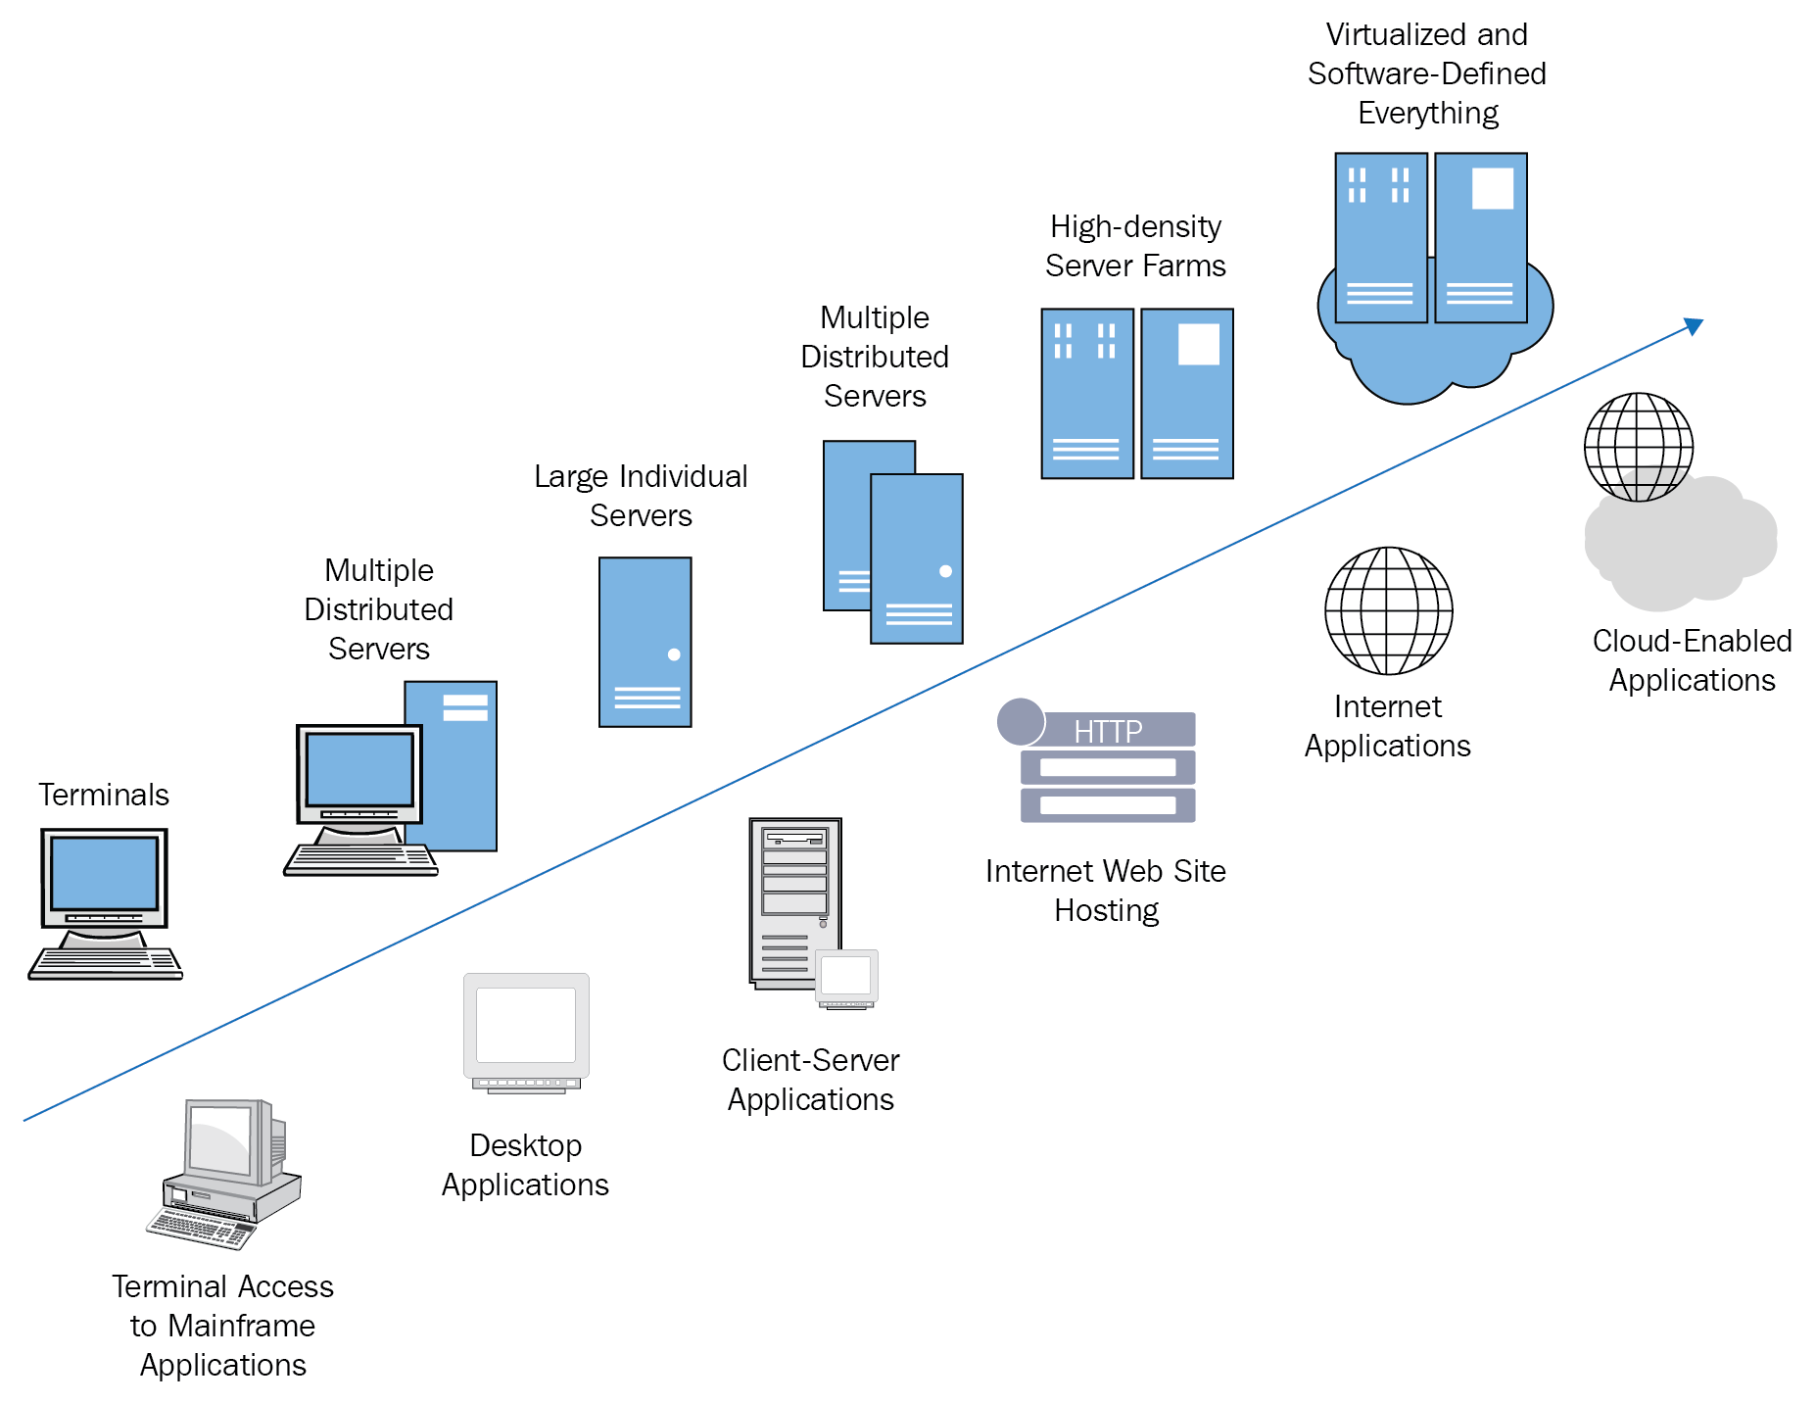
Cloud computing is moving towards greater edge computing, bringing computation closer to data sources to reduce latency for applications like IoT and autonomous vehicles. Security, data privacy, and regulatory compliance continue to be paramount concerns, driving innovations in encryption and governance.
Emerging models include AI as a Service (AIaaS) and Quantum Computing in the cloud, which promise to solve complex problems and further revolutionize industries. Sustainability efforts are increasing, focusing on optimizing data centre energy efficiency and using renewable power sources.

3. CLOUD SERVICE & DEPLOYMENT MODELS

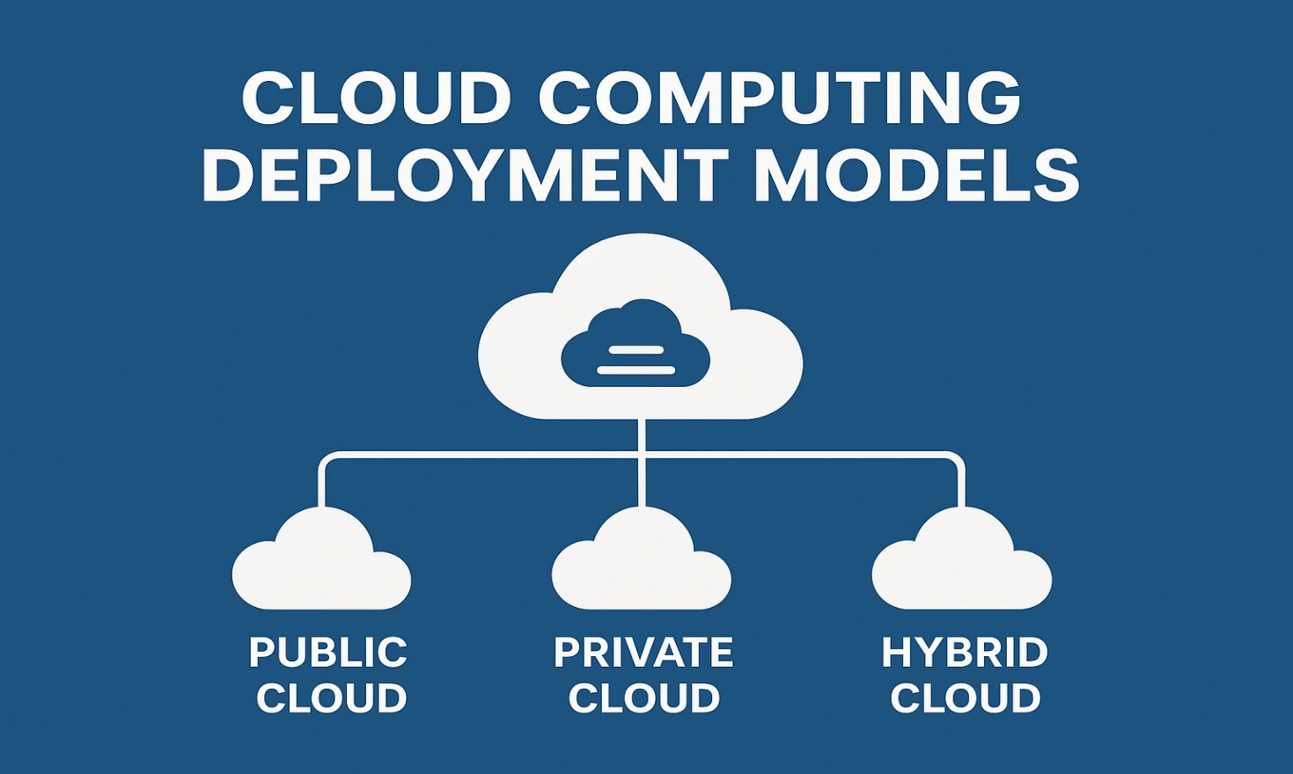
Cloud computing has revolutionized how businesses operate, offering unmatched flexibility, scalability, and cost-effectiveness. One of the key aspects of cloud computing is the cloud deployment model, which determines how cloud services are made available to users. In this article, we’ll explore the types of deployment models in cloud computing, provide real-world examples, and explain how they benefit businesses of all sizes.

What is Deployment Model in Cloud Computing?
A deployment model in cloud computing refers to the specific environment and configuration under which cloud services are deployed. It defines who owns the infrastructure, how it is managed, and who can access it. Different cloud deployment models in cloud computing cater to different business needs, depending on factors like data sensitivity, compliance, scalability, and budget.
Four Deployment Models of Cloud Computing
There are four primary deployment models of cloud computing, each serving a unique purpose. Let’s explore them one by one.
1. PUBLIC CLOUD
- The public cloud is a cloud environment owned and operated by third-party cloud service providers like Amazon Web Services (AWS), Microsoft Azure, or Google Cloud Platform
- All hardware, software, and infrastructure are managed by the provider, and users share the same infrastructure.
Example: Hosting a web application on AWS EC2 instances.
Benefits:
- Cost-effective
- Easy scalability
- No maintenance required by the user
- Highly reliable and redundant
2. PRIVATE CLOUD
- A private cloud is exclusively used by a single organization. It can be hosted either on-premise or by a third-party provider. This model offers greater control and security, making it ideal for industries with strict compliance requirements.
Example: A government agency hosting confidential data on its own private cloud infrastructure.
Benefits:
- Enhanced security and privacy
- Greater control over resources
- Customization as per business needs
3. Hybrid Cloud
- The hybrid cloud combines the best of both public and private clouds, allowing data and applications to move between them as needed. It provides greater flexibility and helps in optimizing workloads.
Example: Running a company’s customer-facing website on a public cloud while keeping sensitive customer data in a private cloud.
Benefits:
- Cost efficiency with better security
- Seamless scalability
- Business continuity and disaster recovery support
4. Community Cloud
- A community cloud is shared among multiple organizations that have similar requirements, such as security, compliance, or policy considerations. It can be managed by the organizations or a third-party provider.
Example: Multiple hospitals sharing a community cloud for storing patient health records.
Benefits:
- Cost shared among multiple users
- Industry-specific infrastructure
- Collaborative platform for related organizations
Benefits of Cloud Deployment Models
Different deployment models offer different benefits of cloud deployment models, including:
- Improved Flexibility: Choose the right mix of services as per business needs.
- Cost Optimization: Pay only for what you use, especially in public and hybrid models.
- Security & Compliance: Private and community models offer strong security features.
- Scalability: Easily scale up or down as per workload requirements.
- Reliability: Built-in redundancies ensure uptime and disaster recovery.

4. INTRODUCTION TO JAVA

Java is a high-level, object-oriented, general-purpose programming language developed by James Gosling and his team at Sun Microsystems in 1995. It was designed with the principle of “Write Once, Run Anywhere” (WORA), which means that Java programs can run on any device or operating system that has a Java Virtual Machine (JVM). Java follows the object-oriented programming (OOP) paradigm, which supports concepts like encapsulation, inheritance, and polymorphism, making it easier to write modular and reusable code. One of Java’s main features is its platform independence. Unlike languages that compile directly into machine code for a specific system, Java code is first compiled into bytecode, which can run on any JVM, regardless of the underlying hardware and operating system.


Java is also known for its simplicity, security, and robustness. It automatically handles memory management through automatic garbage collection, reducing programmer errors. Its strong security features make it a preferred choice for networked and web-based applications. Over the years, Java has evolved with various versions, adding new features and improvements. It is widely used for developing desktop applications, mobile apps (Android), web servers, enterprise applications, and more. Due to its rich API library, large community support, and strong development tools (like Eclipse, IntelliJ IDEA, and NetBeans), Java remains one of the most popular and reliable programming languages in the world today.

4.1 FEATURES OF JAVA
The java features given below are simple and easy to understand. They are also known as java buzzwords.
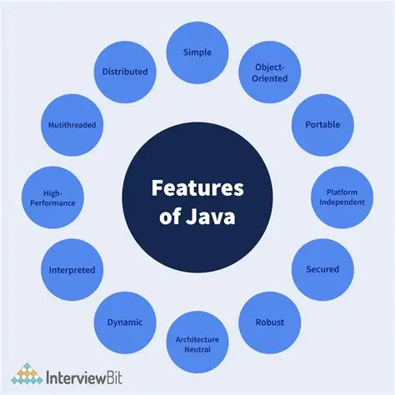

Simple :
The java features given below are simple and easy to understand. They are also known as java buzzwords.
- Java is Simple to write and more readable and eye-catching.
- It has a concise, cohesive set of features that makes it easy to learn and use.
- Many confusing and/or rarely-used features are removed.
2.Secured:
- Java program cannot harm another system thus making it safe.
- No explicit pointer.
- Java Programs run inside virtual machine sandbox.

3.Portable:
- Java programs can execute in any environment for which there is a Java run-time system.
- Java programs can be run on any platform means OS.
- We may carry the java byte code to any platform.
4.Object Oriented:
- Java programming is an object-oriented programming language.
- Java is pure OOP Language.
5.Robust:
- Java encourages error-free programming by being strictly typed and performing run-time checks.
- There is lack of pointers that avoids security problem, automatic garbage collection, exception handling and type checking mechanism in java.
6.Multithreaded:
- Java is a multi-threaded programming language which means we can develop multi-threaded program using Java.
- A multi-threaded program contains two or more parts that can run concurrently and each part can handle different task at the same time making optimal use of the available resources.
- It is said to be advanced to C++ because C++ does not contain any built-in support for multithreaded applications.
7. Architecture Neutral:
- Now talking about C, C++ they are a platform dependent language as the file which compiler of C, C++ forms is an .exe (executable) file which is operating system dependent.
- The C++ program is controlled by the operating system whereas, the execution of a Java program is controlled by JVM (Java Virtual Machine).
8. Interpreted:
The interpreted feature in C++ is very slow because it is interpreted line by line, and makes the system a slower way of running a program than one that has been compiled.

9.High Performance:
- Byte codes are highly optimized.
- JVM can execute them much faster.
10. Distributed:
- Java was designed with the distributed environment.
- Java can be transmitted, run over the internet.
- RMI and EJB are used for creating distributed applications.
11. Dynamic:
Java programs carry with them large amounts of run-time type information that is used to confirm and resolve accesses to objects at run time.
12.Platform Independent:
- Many languages are compatible with only one platform.
- Java was specifically designed so that it would run on any computer, regardless if it was running Windows, Linux, Mac, Unix or any of the other operating systems

5. FRONTEND DEVELOPMENT

INTRODUCTION
Frontend development in cloud computing involves designing and implementing user interfaces that interact with cloud-hosted services and infrastructure. This approach enables scalable, secure, and globally accessible applications. Cloud platforms such as AWS, Azure, and Firebase provide tools for hosting, authentication, and real-time databases, which are commonly integrated into modern frontend workflows.

1.Technologies and Tools
The development process typically utilizes a combination of frontend frameworks and cloud services.
Commonly used technologies include:
- HTML, CSS, JavaScript – for structuring and styling web pages
- React.js or Angular – for building dynamic and component-based interfaces
- Firebase or AWS Amplify – for backend services like authentication and database
- Git & GitHub – for version control and collaboration
- Netlify or Vercel – for deployment and continuous integration
2. Key Development Activities
- Designed responsive UI components using React and Tailwind CSS
- Integrated Firebase Authentication for secure user access
- Connected frontend with Firestore for real-time data updates
- Deployed the application using Netlify with automated build pipelines
3.Challenges Encountered
- Managing asynchronous data flow and state in React components
- Ensuring secure communication between frontend and cloud services
- Optimizing performance for mobile and low-bandwidth environments
4.Learning Outcomes
The internship provided exposure to cloud-integrated frontend development practices. Key learnings included:
- Efficient use of cloud-hosted databases and authentication services
- Deployment strategies for frontend applications on cloud platforms
- Implementation of responsive and accessible design principles
  - COMPONENTS OF JAVA
Following are the components of JVM:
- Stack
- Heap
- Constant Pool
- Code segment
- Program counter
1.Stack:
- Temporary values are stored in frames of a stack.
- It contains the state of Java method invocation.
- While invoking a method, JVM pushes a new frame onto that thread’s Java stack.
- After completion of a single method, the virtual machine pops and discards the frame for that method.
2.Heap:
- The Heap consists of objects.
- The JVM has a heap that is the runtime data area from which memory for all class instances and arrays are allocated.
- It is created at the JVM start-up.
- Heap Memory – Store Java objects
- Non-heap memory – Store Meta data and other loaded classes.
3. Constant Pool:
- Constant pool consists of all constant data. They comprise of
- Numbers
- Strings
- Symbolic names of classes, interfaces and fields
4. Code Segment:
- Code Segment is also known as Method Area.
- It stores class-level data like class structure, method data, static variables, and runtime constant pool. It is shared across threads.

5. Program Counter:
- Tracking of current instruction execution at any moment is done by Program Counter (PC) register.
- It is similar to that of pointer which keeps in track of current instruction in sequence.
- Every time a new thread is created, a PC register is also created simultaneously.
- PC keeps a pointer to the current statement that is being executed in its thread.

HOW TO SET PATH TO RUN A PROGRAM?
The path is required to be set for using tools such as javac, java etc. If user is saving the java source file inside the jdk/bin directory, path is not required to be set because all the tools will be available in the current directory. But if user having his java file outside the jdk/bin folder, it is necessary to set path of JDK.

How to set Temporary Path of JDK in windows?
To set the temporary path of JDK, user needs to follow following steps:
1. Open command prompt
2. Copy the path of jdk/bin directory
3. Write in command prompt: setpath=copied_path

Example:
Set Path = C:\Program Files\Java\jdk1.7.0_03\bi

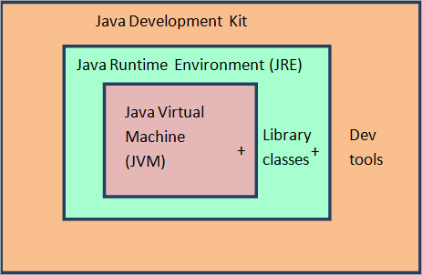

5.2 APPLICATIONS:
The frontend is the part of the application that the user interacts with directly. It's built using a set of web technologies that run within the user's web
browser or as a native mobile app. Here's a breakdown of the key elements:
- HTML
- CSS
- JAVASCRIPT
- FRONT END FRAMEWORKS

HTML (Hypertext Markup Language):
- Role: HTML provides the fundamental structure and content of a web page. Think of it as the skeleton or blueprint of your website. It uses tags to define various elements like headings, paragraphs, links, images, forms, and more.
- Example: When you see a webpage, the text, images, and buttons are all defined within the HTML document. Without HTML, a web page would be just unformatted text.
CSS (Cascading Style Sheets):
- Role: CSS is the styling language that controls the visual presentation and layout of HTML elements. It dictates colors, fonts, spacing, positioning, and how elements appear on different screen sizes and devices.
- Example: CSS makes a webpage visually appealing by setting the background color, font styles, sizes, and how elements are arranged on the page.
JAVASCRIPT:
- Role: JavaScript is the programming language that adds interactivity and dynamic behavior to web pages. It allows webpages to respond to user actions, manipulate HTML and CSS, and communicate with the backend. According to HubSpot Blog, JavaScript controls the behavior of different elements.

- Example: JavaScript enables features like interactive forms with real-time validation, dynamic content updates, animations, image sliders, and communicating with the Java backend to fetch or send data without needing a full page reload.

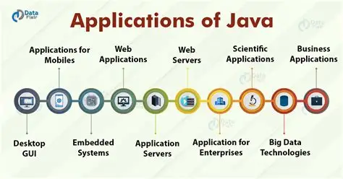

FRONTEND FRAMEWORKS/LIBRARIES:
- Role: Frontend frameworks and libraries are collections of pre-written JavaScript (and sometimes HTML and CSS) code, tools, and conventions that provide a structured approach to building user interfaces more efficiently, and. They abstract away repetitive tasks and provide reusable components, simplifying development and improving code maintainability.
- Examples:
- React.js
- Angular
- Vue.js:

ADVANTAGES OF FRONTEND DEVELOPMENT:
- Improved User Experience: A strong grasp of HTML, CSS, and JavaScript allows developers to design and implement visually appealing, responsive, and intuitive user interfaces, directly impacting user satisfaction and engagement.
- Seamless Integration: Understanding both frontend and backend empowers Java developers to design robust APIs and ensure smooth data flow between the user interface and server-side logic, preventing communication bottlenecks and ensuring cohesive application functionality.
Improved User Experience:
A strong grasp of HTML, CSS, and JavaScript allows developers to design and implement visually appealing, responsive, and intuitive user interfaces, directly impacting user satisfaction and engagement.

Seamless Integration:
Understanding both frontend and backend empowers Java developers to design robust APIs and ensure smooth data flow between the user interface and server-side logic, preventing communication bottlenecks and ensuring cohesive application functionality.
Having expertise in frontend development is paramount for a Full Stack Java Developer, as it empowers them to craft holistic, engaging, and efficient applications. This proficiency extends beyond mere coding and involves a deep understanding of user interface (UI) and user experience (UX) principles to create intuitive and visually appealing interfaces.

The ability to seamlessly bridge the gap between Java's robust backend and the dynamic frontend technologies like HTML, CSS, and JavaScript, often utilizing modern frameworks like React or Angular, is critical. This comprehensive skillset allows developers to ensure smooth integration, streamline development cycles, and more efficiently troubleshoot issues across the entire application stack

6. BACKEND DEVELOPMENT

In Java development, the backend refers to the server-side components of a web application that handle the core logic, interact with databases, manage security, and facilitate communication with the frontend. Java Backend Development. Java is a popular choice for building robust and scalable backend applications. Some key aspects of Java backend development include:
1. Spring Framework (e.g., Spring Boot, Spring MVC)
2. Java Servlets and Java Server Pages (JSP)
3. Database interaction (e.g., Hibernate, JDBC)
4. API design and RESTful web services
5. Security and authentication (e.g., OAuth, JWT)
Java's strengths in backend development lie in its platform independence, strong security features, and vast ecosystem of libraries and frameworks.

How the backend interacts with the frontend?
- Frontend Request: When a user interacts with the frontend (e.g., clicks a button to retrieve data), the frontend sends an HTTP request to a specific API endpoint on the backend.
- Backend Processing: The backend receives the request, processes it (querying the database, executing logic, etc.), and prepares a response.
- Backend Response: The backend sends the processed data back to the frontend via the API.
- API Endpoint: This request is sent to a specific API endpoint (a URL on the backend server) designed to handle that particular action. These API endpoints are often defined using the RESTful architectural style, utilizing standard HTTP methods like GET (to retrieve data), POST (to create data), PUT (to update data), and DELETE (to remove data).
- Frontend Update: The frontend receives the response from the backend and uses JavaScript to parse the data (e.g., deserializing JSON).

CORE JAVA:
- Core Java is the foundational layer upon which the entire backend is built. It provides the essential building blocks, fundamental concepts, and core libraries necessary to develop robust, scalable, and efficient server-side applications.
- Core Java provides the fundamental concepts and skills that form the bedrock of full stack Java backend development, allowing developers to build the underlying architecture, manage data, handle security, and optimize performance before leveraging more specialized frameworks and technologies.
JDBC (Java Database Connectivity) :
In Java application, the backend is responsible for interacting with databases to store and retrieve data. JDBC (Java Database Connectivity) is a fundamental API that enables Java applications to connect to and interact with relational databases. It serves as a bridge, allowing your Java code to execute SQL queries and process the results returned by the database.
The process of interacting with a database using JDBC in a Java backend typically involves the following steps:
- Loading the JDBC Driver
- Establishing a Connection
- Creating Statements
- Executing Queries
- Processing Results
6. Closing Resources
JDBC remains the foundational technology for direct, low-level database interaction. Understanding JDBC is therefore essential for any Java backend developer building data driven applications.
API:
- The backend primarily interacts with the frontend and external services through APIs (Application Programming Interfaces).
- An API is a set of rules, protocols, and definitions that allow different software systems to communicate and interact. It acts as a messenger or a contract between a "client" (like your frontend application) and a "server" (your Java backend).
Types of APIs commonly used in Java backends:
- REST APIs
- Graph OL APIs
- WebSocket APIs
STRING FRAMEWORK:
The Spring Framework is a powerful and popular open-source Java framework that forms the backbone of most full-stack Java backends. It provides a comprehensive ecosystem and numerous modules to simplify and streamline the development of robust, scalable, and maintainable enterprise applications.
Key principles and features:
1.Inversion of Control (IoC) Container
2.Dependency Injection (DI)
3.Spring Boot
4.Spring Data
5.Spring Security

ADVANTAGES OF BACKEND DEVELOPMENT:
- Robust Data Management: The Java backend provides the infrastructure for designing, managing, and interacting with databases, ensuring efficient storage, retrieval, and manipulation of application data.
- Scalability and Performance: Java's inherent features, such as multithreading and robust memory management, along with frameworks like Spring Boot, enable Full Stack developers to build highly scalable applications capable of handling large user bases and complex transactions with optimized performance.
- Enhanced Security: The backend is crucial for implementing security features like authentication and authorization, protecting sensitive data, and safeguarding against vulnerabilities. Java offers built-in security features and a mature ecosystem with tools like Spring Security to ensure application security.
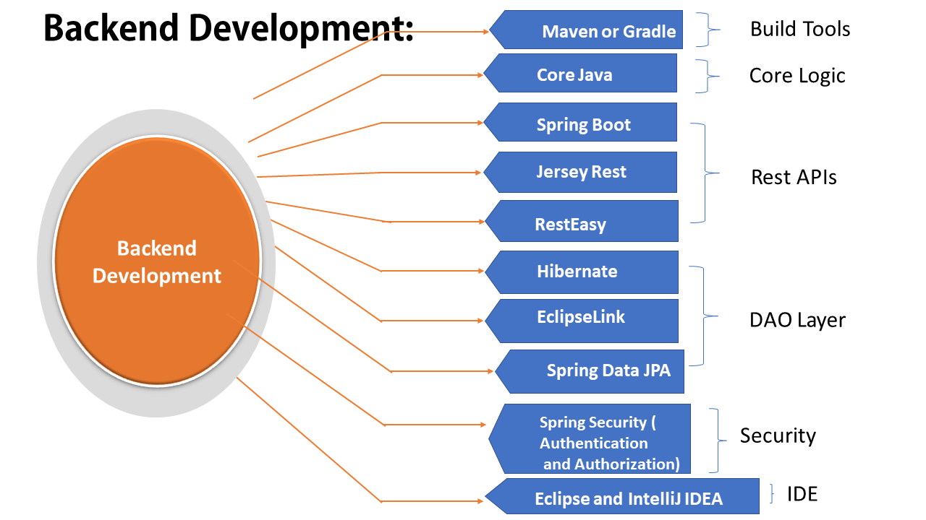
- Complex Business Logic: The Java backend is where the core business logic of an application resides. It processes user requests, executes business rules, performs calculations, and handles integration with external systems or APIs, thereby bringing SSthe application's functionality to life.

7. DATABASE MANAGEMENT

A database is an organized collection of data that can be easily accessed, managed, and updated. It stores information in a structured format—typically in tables with rows and columns—so that users and applications can retrieve and manipulate it efficiently.

Databases are managed using software called a Database Management System (DBMS), which handles tasks like:
- Storing and retrieving data
- Ensuring data integrity and security
- Supporting concurrent access by multiple users
- Providing backup and recovery mechanisms

Importance of Databases in Cloud Computing Using Java
In cloud computing, databases play a central role in enabling scalable, secure, and remote data management. When combined with Java, they become even more powerful for building enterprise-grade applications.

Why Databases Matter in the Cloud?
- Scalability: Cloud databases can grow with your application, handling more users and data without performance loss.
- Remote Access: Data can be accessed from anywhere, ideal for distributed teams and services.
- High Availability: Cloud providers offer automatic backups, replication, and failover systems.
- Cost Efficiency: Pay-as-you-go models reduce infrastructure costs.

Why Java Is a Perfect Fit
- JDBC (Java Database Connectivity) allows Java applications to connect to cloud-hosted databases like MySQL, PostgreSQL, or Oracle.
- Java supports multi-threading and distributed computing, which is ideal for cloud environments.
- Frameworks like Spring Boot and Spring Cloud simplify cloud-native development in Java.

TYPES OF DATABASES IN CLOUD COMPUTING

- Relational Databases (RDBMS)
Relational databases store data in structured tables consisting of rows and columns. Each table has a defined schema, and relationships between tables are maintained using keys. These databases are ideal for applications that require complex queries and strict data integrity. In cloud computing, relational databases are widely used due to their reliability and support for SQL. Popular cloud-hosted RDBMS options include MySQL, PostgreSQL, and Oracle, often deployed using services like AWS RDS, Google Cloud SQL, or Azure SQL Database. Java applications connect to these databases using JDBC, making integration seamless and efficient.

2. NoSQL Databases
NoSQL databases are designed to handle unstructured or semi-structured data. Unlike relational databases, they do not require a fixed schema and can store data in formats like key-value pairs, documents, graphs, or wide-columns. These databases are highly scalable and suitable for real-time applications, big data, and distributed systems. Examples include MongoDB (document-based), Redis (key-value), Cassandra (wide-column), and Neo4j (graph-based). In cloud environments, NoSQL databases are offered as managed services such as AWS DynamoDB or Azure Cosmos DB. Java developers often use specialized libraries or frameworks like Spring Data NoSQL to interact with these systems.

3. Object-Oriented Databases
Object-oriented databases store data in the form of objects, similar to how data is represented in object-oriented programming languages like Java. This approach allows complex data types and relationships to be modelled more naturally. Although less common in cloud platforms, object databases like Object DB or db4o are useful in applications where data structures closely mirror Java classes. They simplify the mapping between application logic and stored data, reducing the need for conversion layers.

4. Distributed Databases
Distributed databases store data across multiple servers or geographic locations. This architecture ensures high availability, fault tolerance, and faster access for global applications.
In cloud computing, distributed databases are essential for handling large-scale systems. Technologies like Apache Cassandra, Google Cloud Spanner, and CockroachDB are designed for distributed environments. Java applications can connect to these databases using native drivers or REST APIs, enabling robust and scalable backend systems.

5. Cloud-Native Databases
Cloud-native databases are specifically built to run on cloud platforms. They offer features like automatic scaling, built-in security, and managed backups. These databases can be either relational or NoSQL, depending on the use case.
Examples: include Amazon Aurora, Google Fire store, and Azure SQL Edge. These services eliminate the need for manual infrastructure management, allowing developers to focus on application logic. Java integrates with cloud-native databases using JDBC, cloud SDKs, or RESTful APIs, depending on the provider.

An example code for java database connection (JDBC)
import java.sql. Connection;
import java.sql. DriverManager;

public class SimpleConnect {
public static void main (String [] args) {
String url = "jdbc: mysql://your-rds-endpoint:3306/student_db";
String user = "admin";
String password = "yourPassword";

try {
Class.forName("com.mysql.cj.jdbc.Driver");
Connection conn = DriverManager.getConnection(url, user, password);
if (conn! = null) {
System.out.println("Connected to MySQL database!");
conn.close();
}
} catch (Exception e) {
System.out.println("Connection failed: " + e.getMessage());
}
}
}

8. API DEVELOPMENT

API development is a crucial aspect of Full Stack Java development, enabling different applications and systems to communicate with each other. In this explanation, we'll delve into the world of API development in Full Stack Java, exploring its importance, types, and best practices.

What is API Development?
API development involves creating a set of defined rules that enable different applications, systems, or services to communicate with each other. APIs act as an intermediary, allowing systems to request data, services, or functionality from each other.
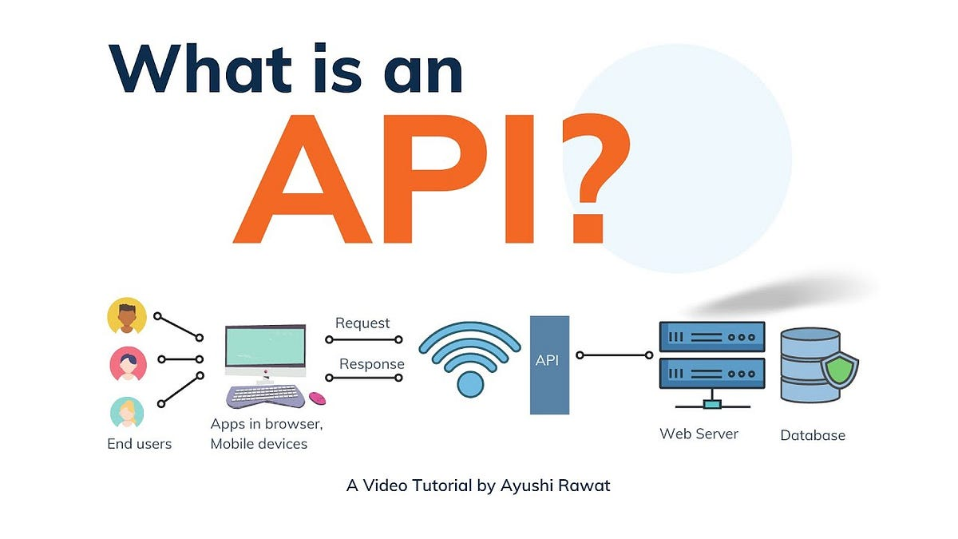
TYPES OF APIS:
1. RESTful APIs: REST (Representational State of Resource) APIs are widely used for building
web services. They use HTTP methods (GET, POST, PUT, DELETE) to interact with
resources.
2. SOAP APIs: SOAP (Simple Object Access Protocol) APIs use XML to define the format of
the data and rely on application layer protocols for message negotiation.
3. Graph QL APIs: Graph QL APIs allow clients to specify exactly what data they need, reducing
the amount of data transferred and improving performance.

BEST PRACTICES:

1.API Design: Design APIs with a clear understanding of the requirements and functionality.
2. Security: Implement security measures to protect APIs from unauthorized access and data
breaches.
3. Documentation: Document APIs clearly and concisely, using tools like Swagger.
4. Testing: Test APIs thoroughly to ensure they meet the requirements and function as expected.
5. Robust error handling is crucial for providing a smooth developer and user experience. Implement a centralized mechanism ( like Spring's @ControllerAdvice ) to gracefully manage exceptions and return consistent error responses, including relevant details for troubleshooting.
6. Version Your API: Implement a versioning strategy(e.g., using the URI path /api/v1/users) early in the process to manage changes and maintain backward compatibility.
7. Structured and Consistent Responses: Define a standard structure for your API responses, often using JSON, to make them predictable and easy for clients to parse.

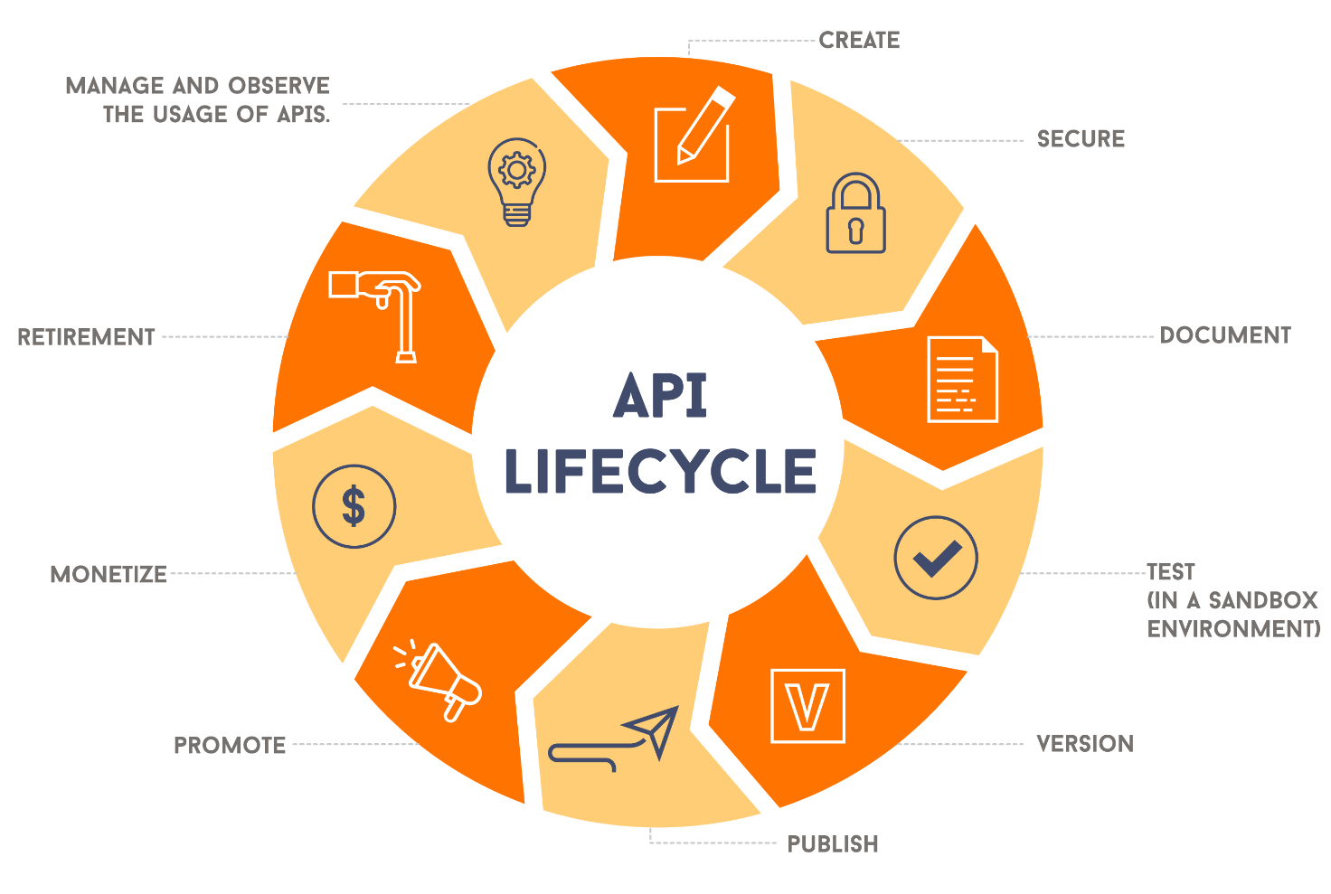

API REQUEST FLOW:
The API request flow is the sequence of steps that an API follows to process an incoming request. Here's a more detailed breakdown of each step:

1. Client Request: The client (e.g., web application, mobile app) sends an HTTP request to the API endpoint. The request includes the HTTP method (e.g., GET, POST, PUT, DELETE), the endpoint URL, and any relevant data or parameters.

2. API Gateway: The API gateway receives the request and performs authentication, rate limiting, and other security checks. The API gateway acts as an entry point for the API and helps to protect it from unauthorized access and malicious requests.

3. API Endpoint: The API endpoint is reached, and the request is processed by the API controller. The API controller is responsible for handling the incoming request and sending a response back to the client.

4. Business Logic: The API controller calls the business logic layer to perform the required actions. The business logic layer contains the logic and rules that govern the behavior of the application.

5. Database Interaction: The business logic layer interacts with the database to retrieve or update data. The database is where the application's data is stored, and the business logic layer uses SQL or other database queries to access and manipulate the data.

6. Response Generation: The API controller generates a response based on the result of the business logic layer. The response includes any relevant data or information that the client NEEDS TO PROCEED.

7. Response Sent: The response is sent back to the client. The client receives the response and can then take further action based on the information provided.

FRAMEWORKS AND LIBRARIES:

1. Spring Boot: Spring Boot is a popular framework for building RESTful APIs. It provides lightweight and flexible way to build web services.
2. JAX-RS: JAX-RS (Java API for RESTful Web Services) is a Java API for building RESTful
web services. It provides annotations and APIs to define resources and methods.
3. Swagger: Swagger is a popular tool for documenting and testing APIs. It provides a userfriendly interface to explore and test APIs.
CHALLENGES:
1. Security: APIs can be vulnerable to security threats, such as data breaches and unauthorized access.
2. Complexity: APIs can be complex to design, develop, and maintain.
3. Documentation: APIs require clear and concise documentation to ensure adoption and usage.
4. Testing: APIs require thorough testing to ensure they meet the requirements and function as
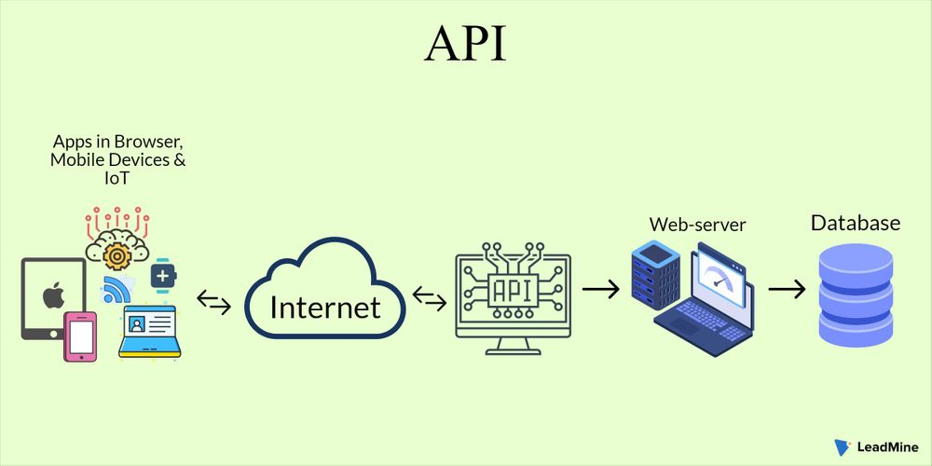
expected.

API development is fundamental to building high-quality Full Stack Java applications. Well
designed APIs, particularly when following RESTful principles, facilitate efficient communication between the frontend and backend, enabling seamless data flow and functionality. Prioritizing robust security measures like authentication, authorization, HTTPS, and input validation is critical to protect sensitive data and prevent vulnerabilities. Implementing a clear versioning strategy and comprehensive, up-to-date documentation using tools like Swagger is essential for API evolution and ease of consumption by other developers.

9. CLOUD INTEGRATION WITH JAVA

Cloud computing has revolutionized the way backend systems are designed and deployed. This internship project focuses on building a Java-based backend application integrated with a MySQL database hosted on Amazon Web Services (AWS) RDS. The objective is to demonstrate how cloud infrastructure enhances scalability, remote accessibility, and operational efficiency in real-world backend development. The project also emphasizes secure connectivity, robust data handling, and practical troubleshooting, all essential skills for modern software engineering.

CLOUD INFRASTRUCTURE SETUP
1.AWS RDS Configuration
The cloud database was provisioned using AWS Relational Database Service (RDS), which offers managed MySQL instances with built-in features like automated backups, multi-AZ deployment, and performance monitoring. Key setup steps included:
- Instance Type: db.t3. micro (suitable for development)
- Storage: 20 GB with auto-scaling enabled
- Public Accessibility: Enabled for external JDBC access
- Security Group: Configured to allow inbound traffic from the development machine’s IP address on port 3306
- Backup & Monitoring: Daily backups enabled; CloudWatch metrics activated
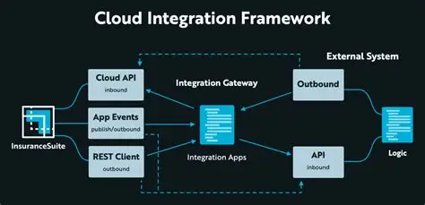

2.Database Initialization
Once the RDS instance was live, the MySQL database schema was created using SQL scripts. Tables were designed to support CRUD operations for user data, with appropriate indexing and foreign key constraints to ensure relational integrity.

JAVA BACKEND AND JDBC INTEGRATION
1.JDBC Driver Setup
The Java application uses the MySQL Connector/J driver () to establish a connection with the cloud-hosted database. The driver was added via Maven:
2.Connection Logic
- The connection string was carefully constructed to include the RDS endpoint, database name, and SSL configuration:
- Connection pooling was implemented using Hikari CP to optimize resource usage and reduce latency during frequent DB interactions.
3.Backend Features
The backend system supports full CRUD operations through DAO (Data Access Object) classes. Each operation includes:
- Prepared Statements for SQL execution
- Exception Handling for SQL and connectivity errors
- Logging using SLF4J for monitoring DB activity

TESTING AND VALIDATION
1.Connectivity Testing
Initial connectivity was verified using:
- And to confirm RDS endpoint reachability
- Java test classes to validate JDBC connection and query execution

2.Unit Testing
JUnit was used to test DAO methods. Mock data was inserted and retrieved to ensure correctness of SQL logic and data flow. Edge cases such as null inputs, invalid credentials, and network failures were simulated to test system resilience.

SECURITY AND BEST PRACTICES
Security was prioritized throughout the project. Key measures included:
- Credential Management: Stored DB credentials in environment variables to avoid hardcoding
- IAM Roles: Used for restricted access to AWS resources
- Firewall Configuration: Limited inbound access to trusted IPs only
- Data Encryption: Enabled at-rest encryption for RDS storage
- Monitoring: AWS CloudWatch used to track CPU usage, query latency, and connection count
These practices align with industry standards for secure cloud-based application development.

10.TOOLS & FRAMEWORKS USED

1.CORE JAVA DEVELOPMENT TOOLS
JDK (Java Development Kit)
- The foundation for compiling and running Java applications.
- Includes the Java compiler (javac), Java Runtime Environment (JRE), and essential libraries.
Maven / Gradle
- Maven: XML-based build tool used to manage dependencies and project structure.
- Gradle: Groovy/Kotlin-based build tool offering faster builds and more flexibility.
- Both are widely used for packaging Java applications and integrating third-party libraries.

- DATABASE CONNECTIVITY TOOLS
JDBC (Java Database Connectivity)
- Standard API for connecting Java applications to relational databases.
- Enables executing SQL queries, managing transactions, and handling result sets.
- Used with cloud-hosted databases like AWS RDS, Azure SQL, or Google Cloud SQL.
Connection Pooling Libraries
- Hikari CP: Lightweight, high-performance JDBC connection pool.
- Apache DBCP: Older but still used in legacy systems.
- These tools optimize database access and reduce latency.

- CLOUD-NATIVE JAVA FRAMEWORKS
Spring Boot
- Simplifies backend development with embedded servers and auto-configuration.
- Ideal for creating RESTful APIs and microservices.
- Easily integrates with cloud services and databases.
Spring Cloud
- Extends Spring Boot with cloud-native features:
- Service discovery (Eureka)
- Configuration management (Config Server)
- Circuit breakers (Resilience4j or Hystrix)
- API Gateway (Spring Cloud Gateway)
Micronaut
- Lightweight framework designed for fast startup and low memory usage.
- Supports dependency injection, reactive programming, and cloud deployments
Quarks
- Tailored for Kubernetes and serverless environments.
- Offers live reload, native compilation, and reactive APIs.
Jakarta EE (formerly Java EE)
- Enterprise-grade framework for building scalable, transactional applications.
- Supports servlets, JSP, JPA, and more often used in cloud-hosted enterprise apps.

4. CLOUD PLATFORM SDKS
AWS SDK for Java
- Provides APIs to interact with AWS services like:
- S3 (storage)
- RDS (relational database)
- EC2 (virtual machines)
- CloudWatch (monitoring)
- Lambda (serverless functions)
Google Cloud Client Libraries
- Java libraries for accessing GCP services:
- Fire store, Pub/Sub, Cloud Functions, Cloud Storage
Azure SDK for Java
- Enables integration with Azure services:
- Blob Storage, Cosmos DB, Azure Functions, Key Vault
5. DEVOPS & DEPLOYMENT TOOLS
Docker
- Containerizes Java applications for consistent deployment across environments.
- Works seamlessly with cloud platforms and CI/CD pipelines.
Kubernetes
- Orchestrates containers, manages scaling, and handles service discovery.
- Ideal for deploying microservices built with Spring Boot or Quarks.
Jenkins / GitHub Actions
- Automates build, test, and deployment processes.
- Integrates with cloud services for continuous delivery.
Terraform
- Infrastructure as Code (IaC) tool for provisioning cloud resources.
- Supports AWS, Azure, GCP,

6. SECURITY & MONITORING TOOLS
Spring Security
- Adds authentication and authorization to Java applications.
- Supports OAuth2, JWT, LDAP, and custom security filters.
Prometheus + Grafana
- Prometheus collects metrics from cloud-deployed Java apps.
- Grafana visualizes performance data and alerts on anomalies.
Cloud Monitoring Tools
- AWS CloudWatch, Azure Monitor, GCP Stack driver: Native tools for tracking logs, metrics, and system health.
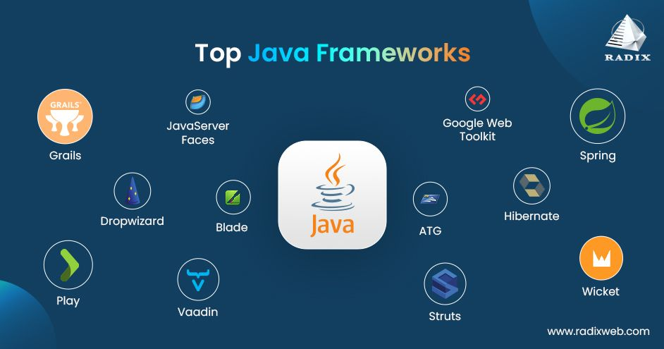

11. TESTING & DEBUGGING

In backend development, especially when integrating cloud-hosted databases and APIs, testing and debugging are indispensable for ensuring system reliability, performance, and maintainability. This internship project involved building a Java-based backend system connected to a MySQL database hosted on AWS RDS. Throughout the development lifecycle, rigorous testing and systematic debugging were employed to validate functionality, identify issues, and optimize performance.

TYPES OF TESTING IMPLEMENTED
- UNIT TESTING
Unit testing was performed using JUnit 5 to validate individual components of the backend system, particularly the DAO (Data Access Object) layer. Each method responsible for database operations and was tested in isolation. Mock objects and test data were used to simulate database interactions without relying on a live connection, allowing for faster and more controlled test cycles.
These tests helped verify that SQL queries were correctly constructed and that the application logic responded appropriately to different inputs and edge cases. For example, tests ensured that null values were handled gracefully and that exceptions were thrown when expected.
- INTEGRATION TESTING
Integration testing focused on validating the interaction between the Java application and the cloud-hosted MySQL database. These tests were conducted using live JDBC connections to the AWS RDS instance. The goal was to ensure that the application could establish a secure connection, execute queries, and handle responses correctly.
Test cases included:
- Verifying successful connection to the RDS instance
- Executing CRUD operations and checking data persistence
- Handling SQL exceptions and rollback scenarios
Integration testing also covered REST API endpoints developed using Spring Boot
- CONNECTIVITY AND SECURITY TESTING
Given the cloud-based nature of the database, connectivity and security testing were crucial. Tests were conducted to ensure that:
- The JDBC URL was correctly formatted
- The AWS RDS instance allowed inbound traffic from the development machine
- SSL configurations (if enabled) were properly handled
Firewall rules and security groups were reviewed and adjusted to allow traffic on port 3306. These tests helped prevent common issues like and errors.

- DEBUGGING METHODOLOGY
Logging and Error Tracing
The application was equipped with SLF4J and Log back for structured logging. Logs were configured to capture detailed information about database transactions, API calls, and system events. When errors occurred, stack traces and log messages provided valuable insights into the root causes.
For example, a was traced back to a missing comma in the statement. Logs also helped identify connection timeouts caused by incorrect firewall settings on the RDS instance.

IDE-Based Debugging
IntelliJ IDEA’s debugger was extensively used to inspect variable states, set breakpoints, and step through code execution. This was particularly helpful in diagnosing logic errors and verifying the flow of data between layers (Controller → Service → DAO).
During one debugging session, a was traced to an uninitialized DAO object due to a missing annotation in the Spring configuration. Fixing this resolved multiple downstream issues.

Manual Inspection and SQL Validation
MySQL Workbench was used to manually inspect database tables, validate schema changes, and run raw SQL queries. This helped confirm whether data was being inserted, updated, or deleted as expected. It also aided in debugging foreign key constraints and indexing issues that affected query performance.

- DOCUMENTATION OF TEST CASES AND BUG REPORTS
All test cases were documented with the following structure:
- Test Case ID
- Description
- Input Data
- Expected Output
- Actual Output
- Status (Pass/Fail)

Bug reports included:
- Issue Summary
- Steps to Reproduce
- Root Cause Analysis
- Resolution Steps
- Date and Developer Notes

This documentation was maintained in a shared repository and included in the final internship report for academic evaluation.

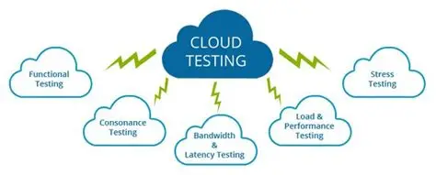

12. SECURITY IN CLOUD APPLICATION

Security in cloud applications is a foundational concern, especially when sensitive data is stored and accessed remotely. In this internship project, the backend system was deployed using Java and connected to a MySQL database hosted on AWS RDS. Ensuring the confidentiality, integrity, and availability of data required implementing multiple layers of security—ranging from network-level protections to secure coding practices. The goal was to safeguard the application against unauthorized access, data breaches, and service disruptions.

- NETWORK AND INFRASTRUCTURE SECURITY
Securing Database Connectivity
One of the first steps in securing the cloud infrastructure was configuring AWS Security Groups to control inbound and outbound traffic to the RDS instance. Only specific IP addresses were allowed to connect to the database on port 3306, minimizing exposure to external threats. This helped prevent unauthorized access and brute-force attacks.
Additionally, VPC (Virtual Private Cloud) settings were reviewed to ensure that the database was hosted in a private subnet, inaccessible from the public internet. This network isolation added an extra layer of protection, ensuring that only the backend application could communicate with the database.
- ENCRYPTION IN TRANSIT
To protect data during transmission, SSL/TLS encryption was enabled for JDBC connections. This ensured that sensitive information—such as login credentials and query results—was encrypted while traveling between the application and the cloud database. The JDBC URL was configured with parameters like and to enforce secure connections.

- APPLICATION-LEVEL SECURITY
Authentication and Authorization
The backend system implemented basic authentication mechanisms to restrict access to API endpoints. User credentials were validated before allowing access to protected resources. Role-based access control (RBAC) was considered for future scalability, allowing different levels of access based on user roles (e.g., admin, developer, guest).
Sensitive operations such as data deletion or modification were restricted to authenticated users, and input validation was enforced to prevent injection attacks.

SECURE CODING PRACTICES
Throughout development, secure coding principles were followed to minimize vulnerabilities:
- Parameterized SQL queries were used to prevent SQL injection.
- Input sanitization was applied to user-provided data.
- Exception handling was implemented to avoid exposing internal system details in error messages.
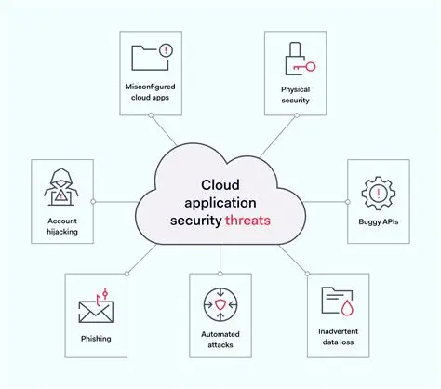
These practices ensured that the application was resilient against common attack vectors and maintained data integrity.

- DATA PROTECTION AND BACKUP
Encryption at Rest
Although AWS RDS offers built-in encryption at rest using AWS Key Management Service (KMS), this feature was reviewed and considered for future implementation. Encrypting data at rest ensures that even if the storage medium is compromised, the data remains unreadable without the encryption key.

Automated Backups
To ensure data availability and recovery, automated backups were enabled on the RDS instance. These backups were scheduled daily and retained for a configurable period. In case of accidental data loss or corruption, the database could be restored to a previous state using AWS’s point-in-time recovery feature.

- SECURITY DOCUMENTATION AND AUDIT
All security configurations and decisions were documented as part of the internship report. This included:
- Security group rules and IP whitelisting
- SSL configuration steps for JDBC
- Authentication flow and access control logic
- Backup schedules and recovery procedures
Periodic audits were conducted to verify that security settings remained intact and aligned with best practices. This documentation not only supports academic evaluation but also serves as a reference for future deployments.

13. DEPLOYMENT & DEVELOPS

DEVELOPMENT PHASE
1. Setting up the development environment
The project began with configuring the local development environment. Java Development Kit (JDK 17) was installed, and environment variables were set to enable compilation and execution. Maven was chosen as the build automation tool to manage dependencies and streamline the packaging process. An IDE like IntelliJ IDEA was used to write, debug, and organize the codebase efficiently.

2. Designing the Application Architecture
The backend system was designed using the Model-View-Controller (MVC) pattern to ensure modularity and maintainability. Java classes were organized into packages such as, and, each serving a distinct role. This structure allowed for clean separation of business logic, data access, and request handling.

3. Implementing Database Connectivity
A MySQL database was created locally to define the schema and test data operations. JDBC (Java Database Connectivity) was used to establish a connection between the Java application and the database. SQL queries were embedded within Java methods to perform Create, Read, Update, and Delete (CRUD) operations. Connection pooling and exception handling were implemented to improve performance and reliability.
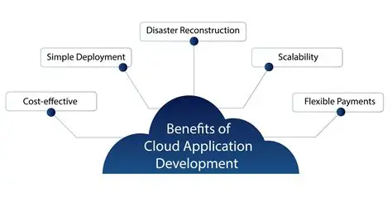
4.Version Control and Documentation
Git was used throughout the development process to track changes and manage versions. A GitHub repository was maintained with regular commits and branches for feature isolation. JavaDoc comments were added to explain the functionality of classes and methods, and a README file documented setup instructions, dependencies, and usage guidelines.

- Testing and Debugging
Unit testing was conducted using JUnit to validate individual components of the backend. Integration testing ensured that the application could interact with the database as expected. Logging was implemented using SLF4J to trace errors and monitor application behavior during runtime. This phase ensured that the system was stable and ready for deployment.

DEPLOYMENT PHASE

1. Migrating the Database to AWS RDS
To simulate a production-like environment, the MySQL database was migrated to Amazon Web Services (AWS) using the Relational Database Service (RDS). A new RDS instance was created with public accessibility enabled, and security groups were configured to allow inbound traffic from the development machine. The database schema was imported using SQL scripts.

2. Configuring Remote Connectivity
The JDBC connection string in the Java application was updated to use the RDS endpoint. Credentials were securely stored, and the application was tested for remote connectivity. Initial issues related to firewall settings and driver compatibility were resolved to ensure smooth communication between the backend and the cloud-hosted database.

3. Packaging and Running the Application
The Java backend was packaged into a file using Maven. This executable file contained all compiled classes and dependencies. The application was run manually on a local machine, connected to the cloud database, allowing for real-time testing and debugging. Logs were monitored to verify query execution and error handling.

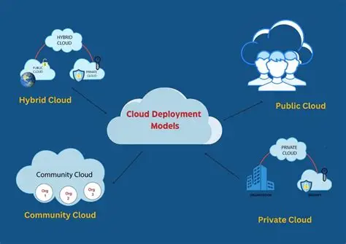

4. Monitoring and Optimization
AWS CloudWatch was enabled to monitor database metrics such as CPU usage, query latency, and connection count. Application logs were analysed to identify performance bottlenecks and optimize SQL queries. Connection pooling settings were fine-tuned to handle concurrent requests efficiently.

5. Planning for CI/CD Integration
Although the current deployment was manual, plans are in place to implement a Continuous Integration and Continuous Deployment (CI/CD) pipeline using tools like GitHub Actions or Jenkins. This pipeline will automate the build, test, and deployment processes, reducing manual effort and improving consistency. The proposed workflow includes automated testing, packaging, and deployment to AWS EC2 or Elastic Beanstalk.

14. CONCLUSION

This internship provided with a solid understanding of cloud computing using java concepts, including syntax, data types, operators, control statements, and arrays. Practical exercises and assignments allowed to apply theoretical knowledge in real coding scenarios, improving accuracy and efficiency.

Through consistent practice, it enhanced the logical thinking and problem-solving abilities, especially in handling loops, conditional statements, and basic file operations. Debugging tasks taught how to identify errors quickly and improve code quality. Working on small projects boosted confidence in implementing Java features effectively.

The internship also improved time management skills and ability to work systematically under deadlines. Interaction with mentors and peers enhanced communication and teamwork abilities. It developed the habit of self-learning and using documentation to explore new concepts.

Overall, the experience bridged the gap between academic knowledge and practical application, giving a strong foundation to pursue advanced cloud computing topics and future software development projects.

